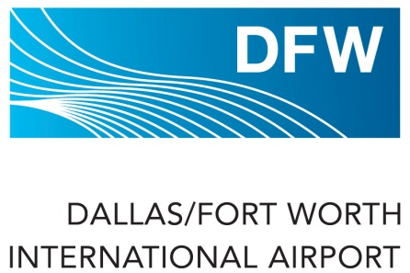
DFW AIRPORT PARKING OFFERS
Valid from February 1, 2014 through January 31, 2015

How to USE the DFW Airport Parking Partner Card!






MUST INSERT PARTNER CARD WITH ETC GROUP LOGO TOWARDS MACHINE FOR DISCOUNT TO APPLY.

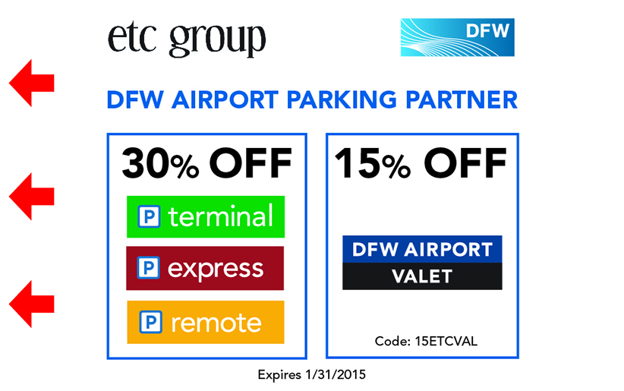

TO REDEEM PARKING DISCOUNT:

- First insert entry ticket, then insert DFW Parking Partner Card into reader PRIOR TO inserting credit card for payment at exit.
  - Entry Ticket  Partner Card  Credit Card
- TollTag Users MUST deactivate TollTag for use at DFW Airport to use Parking Partner Card
  - Deactivate at https://csc.ntta.org; select “User Preferences” after log-in.
- Parking offer valid only for lots displayed on card, not valid in any other lots and/or with any other offers.
- Use of this DFW Parking Partner Card for discounted parking is subject to availability.
- One discount per visit, per customer.
- Duplicates not accepted.
- Not valid with TollTag and/or cash payment.

Valet Parkers: Present Partner Card to Valet Attendant to receive parking discount

- For Reservations, visit www.dfwairport.com/valet or call 972 574 2407, enter Promo Code 15ETCVAL -OR-
- Present Card to Valet Attendant - OR-
- Provide Promo Code 15ETCVAL to Valet Attendant at Check-In to receive parking discount.
- Toll Tag Users please inform the Valet Attendant that you have a TollTag at Check-In.
- Non-TollTag Users will be provided a validation ticket to be used at Airport exit.
  - Insert parking ticket then insert validation ticket into reader at exit.
- Valet Attendant will provide a receipt for your records or will email you a receipt upon request.
